_{Airborne Lidar}
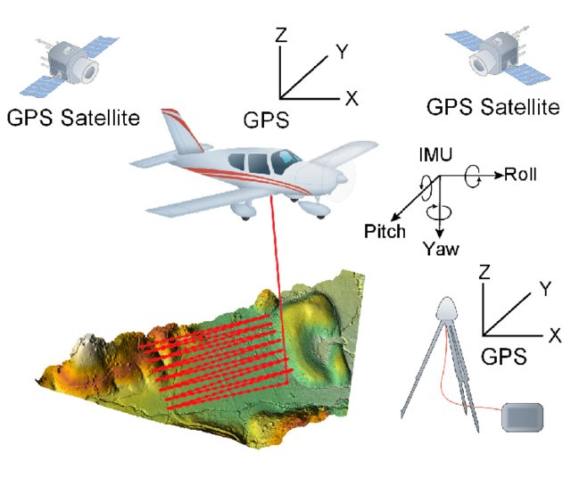

From Alan D. George

Goal | Morphological measurements
Typical area | Salt marshes, mangroves, tidal flats, dunes, beaches
Typical time resolution | Months–decades
Investment costs | < 15,000 per flight
Operation Costs
Labor | Medium
Spatial Coverage | High (> 1 km2)
Time Frequency | Interval
Detail level | low (100–150 mm vertical resolution)

Method
The plane with the airborne Lidar system flies in a certain pattern to cover and collect the data from the study area. The data is processed in GIS software’s and converted in to digital elevation models thru interpolation methods.
Materials
- Airborne LiDAR
Additional information

