Course CU15062 - Integrated Coastal Zone Management

Short description of course set-up
The course Integrated Coastal Zone Management (ICZM) will be taught for the first time at the Delta
Academy in the first semester of the course year 2014-2015, starting in the first week of September
2014. It is an obliged course in the fourth year of the study Delta Management, but the course is open
and recommended for all 4th year Delta Academy students. It is a 7,5 ECTS course. To serve the purpose
of Delta Academy broad courses, the three programmes of the Delta Academy (DM, CE and WM) have
cooperated to develop the content and the learning goals of the new course.
The content of the course is divided in two parts and accompanied by individual assignments in the first
5 weeks and a group assignment from the 5th week on:
• Part 1 exists of 5 theory lectures on the broad concept of ICZM and two introduction lectures on
ICZM in Belgium. During the first 5 weeks the coastal developments around New York after
Hurricane Sandy (Rebuild by design) will be used as study material for the individual
assignments. In the fifth course week the practical assignment at the Belgium coast will be
introduced by an excursion to the project location at the harbor of Blankenberge followed by a
background lecture on ICZM in Belgium and a lecture on silting up of harbors.
• Part 2 exists of 7 lectures on the practical examples of innovative adaptive coastal measures.
During this period the group assignment is executed. At the end of the course (in the week from
11th-17th of January) the students will present their end-results to the project commissioner.

Learning outcomes
On successful completion of this module, students will have:
Acquired, the methodological and conceptual tools necessary for assessing and implementing integrated policies for the coastal area at different scales.
Aims
Understanding of the complexities inherent in the principles of ICZM and governance, linking these theoretical and policy aspects to actual implementations and the difficulties encountered in the field.

Literature
The book that accompanies the course is: Climate of Coastal Cooperation, written by Robbert Misdorp,
2011, ISBN number: 978-90-75502-09-1. This book is for sale as a hard copy, but also available as pdf
and can be downloaded from the internet (www.coastalcooperation.net) or from the VLD. Additional
literature like articles, will be supplied in the classroom and put on the VLD as well.

Grading
The course consists of a theoretical and a practical part. Both parts have to be graded with a score
higher than 5.5. The theoretical part consists of a midterm and final exam. Each exam forms 25% of the
final grade. The practical part forms 50% of the final grade. This part exists of the individual assignment
(35%) and the group assignment (65%).

Content of the lectures

Lecture 1: Introduction to ICZM: coastal areas are introduced and how they are defined (biophysical
and/or policy oriented), a brief history of coastal management. Introduction of individual assignment:
analyzing the results of the Rebuild by design competition (Liliane Geerling)

Lecture 2: Coastal management issues: population growth and urbanization, coastal use (resource
exploitation, infrastructure, tourism and recreation, conservation reserves and protection of
biodiversity), impacts of human use, administrative and legal issues. (Liliane Geerling) Plus guest lecture
by bureau PalmBout Urban Landscapes on the plan ‘Living with the bay’ in which they collaborated with Interboro / Apex / Bosch Slabbers / Deltares / H+N+S / Palmbout / IMG Rebel with Center for Urban Pedagogy, David Rusk, NJIT Infrastructure Planning Program, Project Projects, RFA Investments, TU Delft.

Lecture 3: Major coastal management and planning techniques: administrative coastal management and
planning techniques, social coastal management and planning techniques and technical approaches to
coastal planning and management. (Liliane Geerling) Plus guest lecture by bureau Urbanisten on the plan ‘New Meadowlands: Productive City + Regional Park’ in which they collaborated with MIT CAU + ZUS + URBANISTEN with Deltares; 75B; and Volker Infra Design.

Lecture 4: Coastal management planning (statutory basis, requirements of coastal management plans,
degree of plan integration, designing a framework, international context). (Liliane Geerling)

Lecture 5: Spatial plans for the Belgium coast (guest lecture rijksbouwmeester Vlaanderen)

Lecture 6: Silting up of coastal harbors (Bram Verkruysse)

Lecture 7: Coastal Cooperation and worldwide examples (guest lecture Robbert Misdorp)

Lecture 8: Eco tourism (Bram Verkruysse)

Lecture 9: Building with Nature: principles and examples (Joao Salvador de Paiva/Mindert de Vries)

Lecture 10: Sand Nourishment (Joao Salvador de Paiva)

Lecture 11: Flood-proof architecture (guest lecture by Waterstudio)

Lecture 12: Energetic coasts (salinization/fresh water, wind energy, solar energy, tidal energy) (guest
lecture)

Lecture 13: Adapting to cyclone storm surges (Joao Salvador de Paiva)

Lecture 14: Mangrove replanting/ Floating vegetable bed cultivation (Bram Verkruysse)

Content of the individual assignment
“When Hurricane Sandy devastated communities in the region, we were reminded of the importance
that climate change will have in all development and planning for our communities to become more
resilient and sustainable.”
Shaun Donovan, Secretary of the US Department of Housing and Urban Development (HUD)
To address these challenges, U.S. HUD Secretary Donovan launched Rebuild by Design in June 2013 as a
multi-stage design competition to develop innovative, implementable proposals that promote resilience
in the Sandy-affected region. From 148 international applicants, 10 interdisciplinary teams were
selected to participate in Rebuild by Design’s year-long process and competition. These teams were
made up of practitioners ranging from architects, landscape-architects to regional and transportation
planners, engineers and community organizers. June 2nd 2014 six winning plans were selected to be
worked out. Your task is to critically analyze one of the winning proposals and to write a report on the
strengths, weaknesses, opportunities and threats of the chosen proposal from the perspective of ICZM.
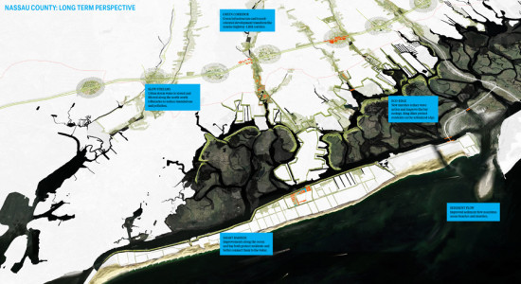
‘Living with the bay’

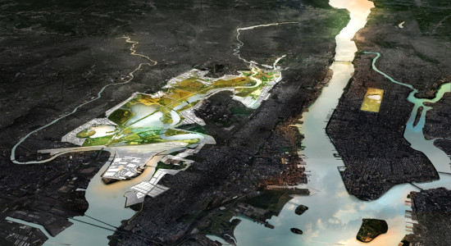
‘New Meadowlands: Productive City + Regional Park’

Content of the group assignment
After the fifth lecture (in the week of October 5th) an excursion will be made to the project location, for
the practical assignment. Not only to explore the area, but also to have talks/interviews with the local
stakeholders. The project area for the practical assignment is at the Belgium coast. The project is located
in the harbor of Blankenberge. The students need to develop an advice for a seaward extension of the
breakwaters in Blankenberge with the dual purpose of preventing silting up of the harbor entrance and
the natural sedimentation of the bathing zone. This siltation is a such a serious problem, that even
during the holiday season sometimes yachts are not able to enter or leave the harbor and extra
dredging needs to be executed. Some of the measure one can think of are:
• To extend or raise existing dams
• To extend or raise existing groynes
• To build new dams at another location
• To design a foreshore, or alike
