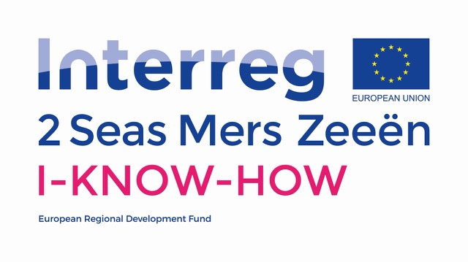

Interview Guide I-KNOW-HOW

June 2019



Table of Content

What - Qualitative research 3

The interview 3

Semi-structured interview 3

Who - The interview participant 5

How – Conducting the interview 6

The interview structure 6

Phrasing ad hoc interview questions 7

Interview probes 7

The silent probe 8

The uh-huh probe 8

Get more details 8

Get feelings, thoughts, rationale 8

The interview topics/questions list 9

How - Interviewer skills 10

Recognising a difficult interview partner 10

Taking notes 11

Recording the interview 12

Why - After the interview 13

Transcribing the interview 13

Digitalising the interview data 13

The consent form 13

References 14

# What - Qualitative research

I-KNOW-HOW is a project that is interested in the experiences of people confronted with cancer and the return to work process. Their narratives form the base and play a vital role throughout all stages of the project as well as in the outcome. To collect these stories about the ***experiences*** and ***feelings*** of people confronted with cancer and the return to work process, I-KNOW-HOW uses qualitative research.

Qualitative research is a form of social inquiry that focuses on the way people describe and make sense of their experiences and the world in which they live (Holloway and Wheeler 2011). Its aim is to explore people’s behaviour, views, feelings and experiences, as well as the contexts and structures of their lives (Charmaz, 2006). The goal of qualitative research is ***understanding***. In I-KNOW-HOW, we treat the people we study as human beings not as inanimate objects. We try to gain access to their experiences and perceptions by ***listening*** and ***observing***and***reflecting****.*

In qualitative research the focus is on the people we talk to. However, to understand more about the ***experiences*** and ***feelings*** of people confronted with cancer and the return to work process, the interviewer/researcher must be open-minded. Though you cannot help having some ‘hunches’ about what you may find when you are going to talk to people. Especially if you are familiar with the setting and some of the literature on the topic. Therefore, as Fetterman (2010, p.1) proposes ***‘begin with an open mind, not an empty head’***.

## The interview

There are many different ways in which qualitative research can be conducted. For I-KNOW-HOW interviews have been chosen as the method at hand. But what is an interview? ***An interview is a conversation with a purpose***. It is a dialogue between people, there to not only gain knowledge but to exchange knowledge. The interviewer and interviewee are conversational partners (Rubin and Rubin, 2014). Yet, the conversation is there for a purpose. In case of I-KNOW-HOW, the aim of the conversation (or interview) is to gain knowledge about the experiences and feelings of people confronted with cancer and the return to work process. At the end of the interview, the knowledge of both conversational partners is greater than at the beginning. Especially the interviewer/researcher knows more about the topic than at the start of the conversation.

## Semi-structured interview

Also, the interview itself can be carried out in different ways. For I-KNOW-HOW semi-structured interviews shall be used to gain knowledge about the topic.

In semi-structured interviews you have a list of topics and/or questions to

be covered. The list for I-KNOW-HOW is a separate document (Interview Topic List) and can form a checklist for the interviewer during the interview. However, the list of topics/questions covered may vary from interview to interview. This means that you, as an interviewer, may use some questions in particular interviews, given a specific context that is encountered. The order of questions may also vary depending on the flow of the conversation. On the other hand, additional questions may be required to explore more about the topic.

As discussed in chapter 3, the form of the question is important to gain as much information as possible. The Interview Topic List contains as many open questions as possible. However, during the interview more questions will pop up. How to do this shall be discussed in chapter 3. The agenda of the interview is flexible and need always be adjusted to the interview participant and their individual answers. **Remember: No interview is identical!**

# Who - The interview participant

I-KNOW-HOW is interested in the experiences of people confronted with cancer and the return to work process. A closer look at the return to work process shows that this can entail a variety of people. First of all, the person with cancer, oftentimes in this context referred to as the ‘employee’. But also, the person employing the person with cancer, the employer. For I-KNOW-HOW a selection is made of target groups that could help to gain a better understanding of cancer and the return to work process. They are shortly discussed as well as the number of people that need to be interviewed in the different categories, in the table below.

|  |  |  |
| --- | --- | --- |
| Target Group | Number of interviews | Note |
| Employees with cancer  People who recently received a diagnosis of cancer, or are recovering from cancer, or are people in a post-treatment phase | 20 per region, 80 in total | This is the largest group. Some information is already available on their experiences when they return to work. The interview questions are therefore more structured for this target group. |
| Employers  The management team of small to medium to large companies (excluding multinationals) | 10 per region, 40 in total | Some literature is available about this target group. Yet, there are many more things to know. Interview questions are therefore less structured. |
| (Para)medical professionals  Oncologists, nurses, occupational therapists and social workers | 10 per region, 40 in total |  |
| Job coaches  Professionals, volunteers or patient experts who guide employees with cancer in their journey to return to work | 5 per region, 20 in total |  |

Table 1: Who to interview

# How – Conducting the interview

Having a casual conversation is for most people a natural thing to do and requires little structural and strategical thinking. Interviewing requires this relaxed conversational pose while at the same time asks for a strategical mindset. The following paragraphs try to form a practical guide in how to interview.

## The interview structure

Every interview has a beginning, a middle, and an end. For every phase of the interview you need different kind of questions.

1. Introductory questions.

These questions are there to help the participant relax and talking. Make them feel at ease and trust you.

* + 1. Introduce yourself
    2. Explain the aim of the interview. Why do you want to talk to this person and about what
    3. Make clear that their input matters and is important. Thank them for their cooperation.
    4. Ask permission for recording the interview. Explain why you would like to record this (see p. 10 – Recording the interview)
    5. Explain what happens to the information.
    6. Make clear the information is treated with care and that all data will remain anonymous.

Where your interview partner has not met you before, the first few minutes of conversation will have a significant impact on the outcome of the interview. Often interviews take place in a setting that is unfamiliar to you. Still, it is your responsibility to start and shape the conversation.

1. Prepared questions/topics

Remember that the aim of the interview is to explore the topic deeply. Use follow-up questions and probes to deepen the interview. This requires you to ‘think on your feet’ and can use up a lot of energy.

1. Ensure you start with the profile and the context of the participant. Who are you talking to? A possible starting question could be: *‘Tell me something about yourself’.*
2. After you gained information about the profile and context of your participant use the Interview Topic List and start with the first open question.
3. Concluding comments
4. Close the interview with some small talk about an easy subject.
5. Thank the participant and make sure he or she is happy with the conversation.
6. Ask for contact details (e.g. email address) to follow up on the interview.
7. Ensure the conversation shall only be used for the purpose of this research.

## 

## Phrasing ad hoc interview questions

As explained in chapter 1.2, there will be situations during the interview where there is a need for further questions to gain a deeper understanding of things. These questions need to be made ad hoc and ask for improvising. However, there are general rules that can help you phrase these questions at the spot.

* Questions should be easy to understand by the participants and be sensitive to their background.
* The questions should be short, clear and a neutral as possible.
* They should be phrased so participants have the opportunity to talk rather than give short answers.
* Questions should not be factual and demand ‘yes’ or ‘no’ answers.
* They should only contain one single question, not two at the same time.

At the same time there are different types of questions. As explained, I-KNOW-HOW aims to gain an understanding about the experiences and feelings of people confronted with cancer and the return to work process. Your questions could therefore be aimed at the behaviour of people in certain situations. What does your interview participant think about a topic to gain an insight of their opinions and values. I-KNOW-HOW will also include desk research. By asking knowledge questions you can support this desk research with real-life examples. This also includes the experience questions as, for example, regulations on paper are often experienced different by people in real-life situations. And last, you can ask about feelings rather than what a person thinks.

* Behaviours;
* Opinions/values; what the person thinks about the topic
* Knowledge; to get facts about the topic to support desk research
* Feelings; what a person feels rather than what a person thinks

While preparing the interview it is good to think about some possible questions which could be of importance to the context in which you are conducing the interview. Write these down on the I-KNOW-HOW Interview Topics List that you take with you to the interview.

## Interview probes

During an interview you often want or need more information than you get when you ask a question. Probing is asking follow-up questions when you do not fully understand a response, when answers are vague or ambiguous or when you want to obtain more specific or in-depth information. There are different probes you can use.

### The silent probe

This might be the most effective of all interview probes, but also the hardest one to master. Imagine a participant begins telling you about their life with cancer but falls short from giving the details you need. Your first response might be to ask more questions about the statement or move on to the next question. ***Or you can choose to remain silent***. The unavoidable silence will then fill the room, allowing the participant to naturally fill that silence with a more detailed response. This sounds easy but is much harder in practice. People dislike uncomfortable silences, so you will find it awkward at first, much more than your participant. But if you can get past this, it can be used to your advantage: the more they talk, the more insights you will get. You can use the 5 second rule. During the silence you count to 5 in your head to distract yourself from the silence in the room. Most of the time people will start talking within this time.

### The uh-huh probe

The uh-huh probe is something people most of the time use naturally. ‘Yes I see’, ‘Right, uh huh’ ‘Mmm hmm’ are all common sounds that are often used by the interviewer. These probes are reaffirming what is being said by the participant is ok. Make sure you are genuine with the probe as the participant may feel you are trying to rush them through the conversation. This probe can be used in combination with the silent probe which can make a very powerful combination in gaining insights from the participant.

### Get more details

Sometimes you need more detail and the silence probe is not working or might not suite the moment. I that case you can use one of the following probing questions.

* Can you give me an example?
* Can you tell me more about that?
* How did others respond to this?
* How do you do that?

### Get feelings, thoughts, rationale

As discussed before, feelings, behaviour, experiences are all type of questions that can help you gain more understanding. Below are a few questions which can help you gain more depth and detail.

* Why was that important to you?
* Why does that stand out in your memory?
* Why do you think you noticed that?
* What motivated your response?
* How did you feel about that?

In broad terms, probing questions often begin with ***“What”*** or ***“How”*** because they invite more detail. Questions that begin with ***“Do you…”*** or ***“Are you…”*** invite personal reflection. ***“Why”*** questions can be problematic. They may put the respondent on the defensive or result in little useful information and require additional probing.

## The interview topics/questions list

Separate document.

# How - Interviewer skills

Except from how to carry out the interview, you as an interviewer, need some skills as well as some techniques.

Interpersonal skills used in everyday social life are important in an interview. Make eye contact with your interview partner, make sure you have a relaxed body language, and show an interest in what people say. **Listen!** BUT – The need to strike a relaxed pose is one of the most stressful aspects of interviewing (O’Reilly, 2005).

As interviewer, you are the main instrument and building a relationship with your interview partner is crucial to gain good high-quality information about the topic. Hard work is needed to build and sustain this relationship during the interview.

*“In order to gain access to the true thoughts and feelings of the participants, researchers adopt a non-judgemental stance towards the thoughts and words of the participants. The relationship should be built on mutual trust. The listener becomes the learner, while the participant is the teacher”* (Holloway and Wheeler, 2011).

As an interviewer you must always have attention for your interview partner. Empathise and encourage them in order to get the whole story. However, ensure you stay with the topic at hand. Robson (2002) says that you should enjoy the interview opportunity, or at least appear to do so.

Make sure you do not become a participant of the interview yourself. As an interviewer you stay as objective as possible. You stay on the side-line, observe, take information to you but do not tell too much about yourself. Stay with the main topic of the interview and deviate from it as little as possible.

## Recognising a difficult interview partner

Inevitably, during the course of your interviews you will meet some people who are difficult to interview. The table below summarises the most common difficulties and provides possible suggestions to overcome these.

|  |  |
| --- | --- |
| Recognised difficulty | Suggestion |
| Participant appears willing only to give  monosyllabic answers, these being little  more than ‘yes’ or ‘no’ | Reasons for this are varied.  If it is due to limited time, or worries about  anonymity, then this can be minimised by  careful opening of the interview.  If the participant gives these answers despite such precautions, try phrasing your questions in as open a way as possible; also use long pauses to signify that you want to hear more. |
| Participant repeatedly provides long  answers which digress from the focus of  your interview | Although some digression should be tolerated,  as it can lead to aspects about which you  are interested, you will need to impose  more direction.  This must be done subtly so as not to cause  offence, such as by referring back to an earlier  relevant point and asking them to tell you  more, or requesting that they pause so you can  note down what they have just said. |
| Participant starts interviewing you | This can suggest that you have created rapport.  However, you need to stress that you are  interested in their opinions and that, if they  wish, they can ask you questions at the end. |
| Participant becomes noticeably upset during  the interview and, perhaps, starts to cry | You need to give your participant time to  answer your question and, in particular, do not  do anything to suggest that you are feeling  impatient.  If your participant starts crying or is obviously  very distressed, it is probably a good idea to  explain that the question does not have to be  answered.  Do not end the interview straight away as this is  likely to make the participant even more upset. |

Table 2: Difficult interview participants and suggestions on how to address them (*Source*: King, 2004).

## Taking notes

As well as audio-recording your interview it is important to also make notes as the interview progresses. In addition to providing a back-up if your audio-recording does not work, this provides another way to show that your interview partner responses are important to you. If

possible, immediately after the interview has taken place you should compile a full record

of the interview (Robson 2002), including contextual data. Where you do not do this, the

exact nature of explanations provided may be lost as well as general points of value.

There is also the possibility that you may mix up data from different interviews, where

you carry out several of these within a short period of time and you do not complete a

record of each one at the time it takes place. You therefore need to allocate time to write up a full set of notes soon after the event.

In addition to your notes from the actual interview, you should also record the following contextual data:

* The location of the interview (e.g. the organisation, the place)
* The date and time
* The setting of the interview (e.g. was the room quiet or noisy, could you be overheard were you interrupted?)
* Background information about the participant (e.g. role, post title, gender)
* Your immediate impression of how well (or badly) the interview went (e.g. was the participant reticent, were there aspects about which you felt you did not obtain answers in sufficient depth?)

## Recording the interview

Most of the time interviews are audio-recorded, where permission is given. ***Always ask the interview partner if they agree with recording the conversation.*** Ensure them the recording shall only be used for transcribing purposes.

During the interview, you will be interested in both what your interview partners say and the way in which they say it. By audio-recording the interview, it is easier to concentrate and listen attentively to what is being said. Also, the expressions and other nonverbal cues the interviewee is giving when they are responding can be recognised more easily. However, as discussed in the previous paragraph, it is also helpful to make brief notes as well in order to maintain your concentration and focus. This is important because, although audio-recordings can capture the tone of voice and hesitation, they do not record facial expressions and other non-verbal cues. Most people have their own means of making notes, which may range from an attempt to create a verbatim account to a diagrammatic style that records key words and phrases, perhaps using mind mapping. Within I-KNOW-HOW there is no specific method you need to maintain for note taking. It should work for you. The task of note taking is sometimes a demanding one. Most interview partners recognise the demands of note taking and act accordingly.

You should always ask permission to audio-record an interview. It is advised that you explain why you would prefer to use a recorder rather than simply requesting permission. Where it is likely to have a negative effect on the interview, it is better not to use a recorder. However, most interview partners adapt quickly to the use of the recorder. It is more ethical to allow your interviewee to maintain control over the recorder so that if you ask a question that they are prepared to respond to, but only if their words are not audio-recorded, they have the option to switch it off. It will inevitably be necessary to make notes in this situation.

# Why - After the interview

Obviously, you are talking to all your interview participants for a reason, or even, multiple reasons.

Figure 1: Steps in the I-KNOW-HOW WP1 process

After you completed the interview there are still a few steps to take.

## Transcribing the interview

All interviews need to be transcribed, i.e. they must become fully written out texts. Therefore, all interviews need to be recorded in order to transcribe them***.***

* Uh’s & Ah’s can be left out of the transcription they are of importance to the context of the interview **UNLESS**
* Silences can be left out of the transcription **UNLESS** they are of importance to the context of the interview

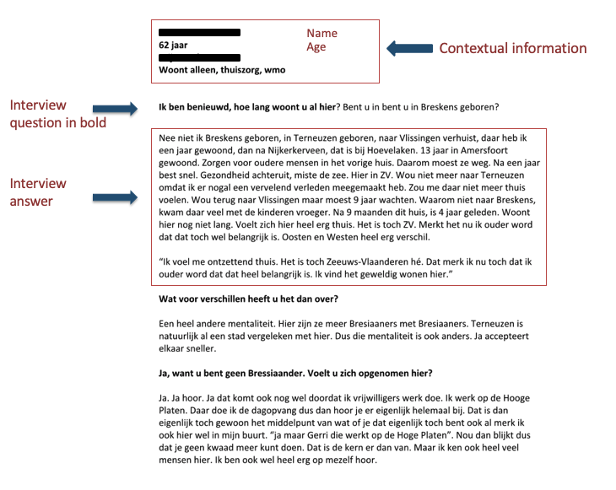

Figure 2: Example interview transcription

## Digitalising the interview data

* Every interview partner has an own digital folder containing the following files
  + The audio recording
  + The transcribe record
  + Notes
    - Contextual data
  + Possible notes made on the interview topics/questions list (scan)

# The consent form

In some countries and in some cases, you will need a consent form. When you choose a third party to transcribe the interviews you will need a processing agreement (verwerkingsovereenkomst).

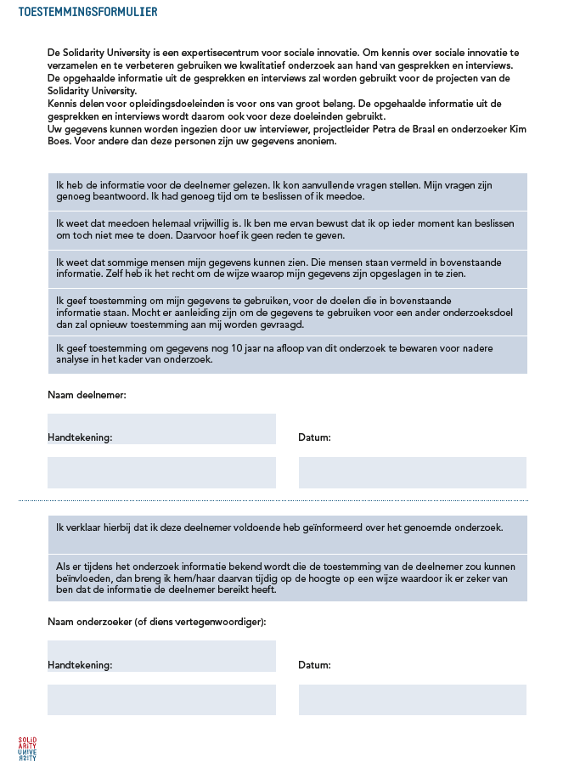

Figure 3: Example informed consent Solidarity University

# References

Berg, B.L. (2001) *Qualitative research methods for the social sciences.* Boston: Allyn and Bacon – Pearson Education Company.

Charmaz, K. (2006) *Constructing Grounded Theory. A Practical Guide through Qualitative Analysis.* London: Sage.

Holloway I. & Wheeler S. (2011) *Qualitative Research for Nursing and Healthcare.* Oxford: Wiley-Blackwell.

O’Reilly, K. (2005) *Ethnographic Methods* London, Sage.

Rubin, H.J. & Rubin, I.S. (2005) *Qualitative Interviewing: The Art of Hearing Data*. 2nd ed. Thousand Oaks: Sage.

Saunders, M., Lewis, P. & Thornhill, A. (2009) *Research Methods for Business Students – Fifth Edition.* Essex: Pearson Education Limited.