Erosion Pin

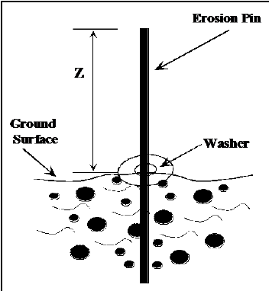

|  |  |
| --- | --- |
| **Goal** | Morphological measurements |
| **Typical area** | Salt marshes, mangroves, tidal flats, dunes, beaches |
| **Typical time resolution** | Weeks–months |
| **Investment costs** | < €5 |
| **Operation Costs** |  |
| **Labor** | High |
| **Spatial Coverage** | spot |
| **Time Frequency** | interval |
| **Detail level** | High (~ 10 mm vertical resolution) |

**Method**

Pins are inserted throughout the surveyed cross sections. The steel pins are 0.6 m long with a diameter of 10 mm and were inserted perpendicular to the particular surface (e.g., pins in the bank were horizontal and pins on the top of slump blocks were vertical) so that 0.3 m was exposed. The length of the exposed portion of each pin was measured on a monthly basis.

**Materials**

* Erosion pins

**Additional information**