# bijlage 6

handleiding voor

* benthosbemonstering en –analyse
* sedimentbemonstering en – analyse
* mini-zandsuppleties

Oesterdam Monitoring

Laboratory and Field work Manual

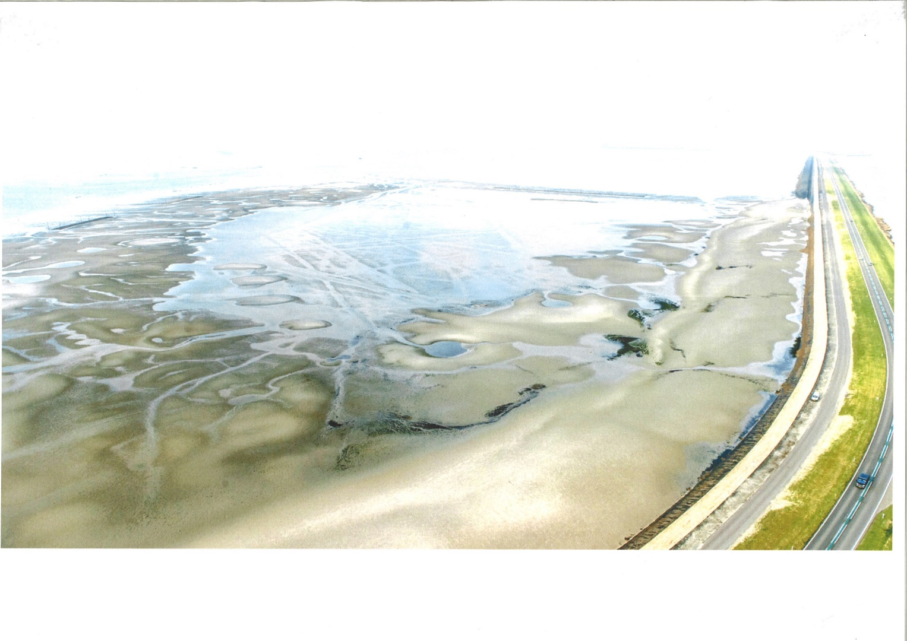

Vlissingen, April 11, 2014

Oesterdam Monitoring

Laboratory and Field work Manual

In 2013 a pilot sand nourishment was constructed on the tidal flat in front of the Oesterdam. It is expected that the nourishment will affect the surrounding ecology. By monitoring characteristics of the tidal flat on a yearly basis the long term impact of the sand nourishment on safety anfd surrounding ecology can be investigated. The monitoring is executed by HZ students of the Delta Academy. This project is coordinated by the Building with Nature Research Group.

Hartog, Eva;

Pesch, Carla;

Salvador de Paiva, João;

Van den Brink, Anneke;

Vlissingen, April 11, 2014

The Oesterdam 4

Monitoring the development of a pilot Nourishment 4

Introduction 4

Natura 2000: the importance of the benthos 5

Methods 6

Benthic community/sediment characteristics 6

Height / sediment compactness 6

Sediment transport 6

Field Work 9

Mini Sand Nourishments Method 15

Lab Work 16

Analysis of Benthic Samples 16

PREPARATION 16

METHODS: SORTING 16

METHODS: SPECIES DETERMINATION 18

Analysis of Sediment Samples 20

Determination of organic content in the sediment 20

GRAIN SIZE DISTRIBUTION ANALYSIS 21

# The Oesterdam

## Monitoring the development of a pilot Nourishment

### Introduction

Coastal erosion represents a serious problem to many coastlines around the globe, and is expected to become even a more serious problem in the next decades due to on-going human-induced changes in estuarine landscapes combined with an accelerated sea-level rise. Efforts to protect coastal areas consist of hard (e.g. dikes) or soft engineering methods (e.g. sand nourishment). In the Oosterschelde tidal inlet dikes need to be reinforced from time to time to meet safety criteria’s. The safety provided by a dike is not only based on the height and material of the construction itself, but also on the presence of tidal flats in front of the dikes. Tidal flats can contribute to the safety of dikes by attenuating wave action in front of them. Since the construction of the Delta works the Oosterschelde tidal inlet is an erosion dominated system. With the construction of the Delta works tidal prism and tidal currents were reduced and due to that tidal channels became oversized with respect to the tidal current. As a result the sediment from the tidal flats is deposited in the oversized channels and the natural dynamic cycle of accretion and erosion changed into a continuous erosion process. When the tidal flats in front of dikes disappear, higher dikes are needed to meet safety criteria’s (Figure 1).

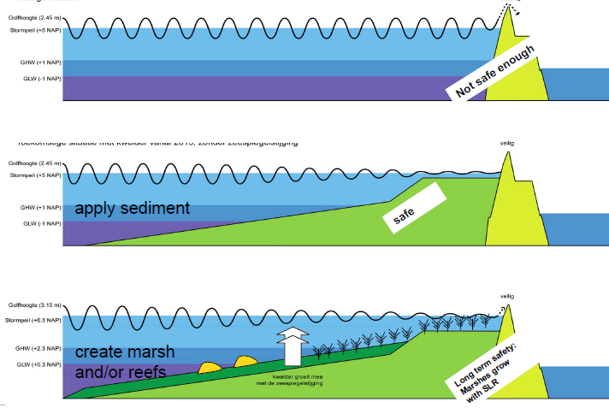

*Figure 1. Situation with and without a tidal flat in front of a dike. Tidal flats attenuate waves reducing the forces of waves on the dikes.*

Slowing down or even stopping the erosion process of tidal flats in front of dikes ca reduce maintenance costs of the dikes and preserve important ecosystems. To preserve a tidal flat in front of the Oesterdam and reduce the maintenance costs a pilot nourishment was constructed in 2013. Around 300.000 m3 of sand was used on the edge of the tidal flat, and near the dike, Figure 2. It is expected that under influence of waves and currents sediment from the nourishment will move northwards, resulting in a gradual increase in elevation of the area on the eastside of the nourishment. It is also expected that the nourishment will have an impact on the local benthic community, sediment composition, sediment transport and height of the tidal flat. To monitor the effect of the nourishment on these characteristics we need to measure all these characteristics on regular basis at the nourishment and its surroundings.

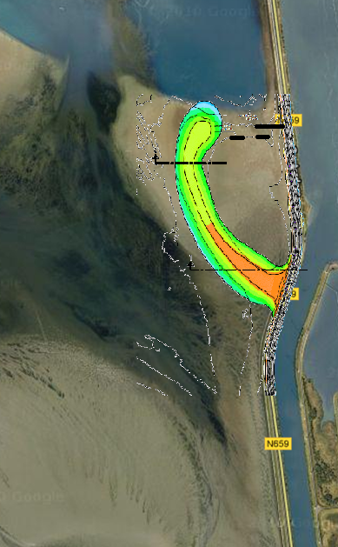

*Figure 2. Proposed sand nourishmenton the intertidal flat in front of the Oesterdam. Waves and currents are expected to distribute the sediment northwards over the tidal flat (arrows).*

### Natura 2000: the importance of the benthos

Natura 2000 is the centrepiece of the EU nature & biodiversity policy. It covers an EU-wide network of protected natural areas and is intended to insure the long-term survival of Europe's most valuable and threatened species and habitats. While these specified areas are protected, the policy does not completely restrict human activity, instead it focuses on the ecological and economical sustainable management of the areas.

Natura 2000 applies to the area around the Oesterdam primarily as a feeding habitat for birds. The area is used as a feeding ground by birds such as the Pied Avocet (kluut), the Common Ringed Plover (Bontbekplevier), the Kentish Plover (Strandplevier), the Sandwich Tern (Grote stern), the Common Tern (Visdief), the Arctic Tern (Noordse stern) and the Little Tern (Dwergstern). These birds feed on the benthos living on and in the sediment, primarily eating worms, shellfish, gastropods and small crustaceans. The presence of these benthic organisms is essential to the habitat suitability for the birds that either stay for a breeding season or use the area as a resting place during their migrations.

The addition of new sand around the Oesterdam has buried and killed much of the benthic life and greatly reduced the food available for feeding birds. It is expected that the benthic organisms will recolonize the newly added sediment, but exactly how long and in what way this will happen is not yet known. Our sampling over time will show us the rate of recovery of the habitat from a bare lifeless sediment to a rich feeding ground for visiting birds.

## Methods

In groups we will investigate sediment characteristics of the area; spatial distribution of the benthic community; height of the tidal flat; and the current sediment transport. In the coming years we will do the same measurements with other students. By comparing this year’s measurements with next year’s monitoring we will show the effects of the nourishment on these characteristics. By monitoring these characteristics of the tidal flat on a yearly basis the long term impact of a sand nourishment can be investigated.

### Benthic community/sediment characteristics

For the benthic community and sediment characteristics we need to answer the question: is there a relation between the presence, abundance and distribution of benthic animals and the substratum? In order to get an idea about the presence, abundance and distribution of benthic animals on the tidal flat in front of the Oesterdam, samples are taken of the benthic community. Sediment samples will be taken on the same locations as well. This way the two variables can be related to each other. Repeating this monitoring on a yearly basis shows the response of the benthic community to the sand nourishment and allows calculating the colonization rate.

To sample the benthic community we will take sediment cores at each sample location. These cores will be sieved in the field after which all organisms will be persevered in a jar and brought to the lab for determination. Besides taking sediment cores lugworm (*Arenicola marina*)abundance will be monitored by counting the number of heaps of digested sand in a 50 x 50 quadrant.

To sample the sediment characteristics we take three samples. One will be used to determine the chlorophyll-a content of the sediment (we won’t do this), two will be taken to determine the sediment organic matter content and particle size distribution of which one will be stored to analyse with the Malvern (we will not do this). To determine the organic matter and particle distribution samples will be placed in the oven at 103 degrees. After drying we take the sample which will be weighed and ashed at 550 degrees for 2 hours. The weight loss is the amount of organic matter. After that we will analyze the particle distribution of the sediment.

### Height / sediment compactness

When constructing the sand nourishment, bulldozers will drive over the tidal flat compacting the sediment. It is unknown if this has an effect on the recruitment of the benthic community. To monitor the effect of the bulldozers we will also measure the compactness of the sediment.

### Sediment transport

The sand nourishment is developed such that sediment of the nourishment will be transported northwards elevating the whole area. This is based on knowledge of water flows. In this subtopic we question if the sediment really is transported northwards. To test this we will construct so called mini sand nourishments during low tide. Mini sand nourishments are round sand nourishments with a radius of 0,5/1 m. Tidal and non-tidal currents and waves will displace the mini sand nourishments and reveal the overall transport of sediments. The construction of mini sand nourishments is an easy and efficient method to study the sediment drift on tidal flats. After some tidal cycles, not only the direction of sediment drift, but also the magnitude can be measured.

The centre of the mini sand nourishments will be marked by bamboos and their coordinates measured with a gps. Sand from the top layer of the tidal flat will be used to build the sand nourishments as this maintains visible for a couple of days. The same amount of sediment (two “Slikkarren” per sand nourishment) will be used for all mini sand nourishments to be able to compare different mini sand nourishments with each other. It is important to form a perfect circle to get a good impression of the changes. For that purpose we used a stick with a ½-1/4 meter line, which can be used to draw a circle. The sediment has to be dispersed symmetrically around the bamboo to a height of about 20cm with the highest point in the centre. After a certain period the nourishment have changed visibly depending on the local hydrodynamics. To measure these changes, a one meter circle is drawn around the bamboo as a reference. After that, the new shape of the nourishment can be drawn. To measure the direction of the sediment flux, a wind rose with the marks at N, NE, E, SE, S, SW, W and NW will be drawn on the sand nourishment. For every direction the distance between the bamboo and the edge of the new shape will be measured. Additionally, it is useful to indicate in which direction the highest point of the nourishment can be found. The construction of the mini sand nourishment will take place on Monday. On Wednesday we will come back to monitor the development of the nin sand nourishments with part of the group, the rest of the students will help with sorting the Benthic samples in the lab.

**Groups**

|  |  |  |  |
| --- | --- | --- | --- |
| **Monday (8:00-14:00 in the field)** | | | |
| **Group** | **Topic** | **students** | **Supervisor** |
| 1 | Benthic | **4** |  |
| 2 | Benthic | **4** |  |
| 3 | Benthic | **4** |  |
| 4 | Benthic | **4** |  |
| 5 | Benthic | **4** |  |
| 6 | Benthic | **4** |  |
| 7 | sediment | **4** |  |
| 8 | sediment | **4** |  |
| 9 | sediment | **4** |  |
| 10 | Height / sediment compactness | **4** |  |
| 11 | Sediment transport | **6** |  |
| 12 | Sediment transport | **6** |  |
| **Tuesday (09:00 – 12:15 Ecolab and Concrete Lab)** | | | |
| From 1-5 | Organic Matter and Particle size distribution |  |  |
| From 6-10 | Determination benthos |  |  |
| **Tuesday (13:00 – 17:00 Ecolab and Concrete Lab)** | | | |
| From 1-5 | Determination benthos |  |  |
| From 6-10 | Organic Matter and Particle size distribution |  |  |
| **Wednesday (09:00 – 12:15 Ecolab and Concrete Lab)** | | | |
| From 1-5 | Organic Matter and Particle size distribution |  |  |
| From 6-10 | Determination benthos |  |  |
| **Wednesday (13:00 – 17:00 Ecolab and Concrete Lab)** | | | |
| From 1-5 | Determination benthos |  |  |
| From 6-10 | Organic Matter and Particle size distribution |  |  |
| **Wednesday (09:00 – 17:00 Field)** | | | |
| 11,12 | Height/sediment compactness | **12** |  |

## Field Work

Group 1 to 10

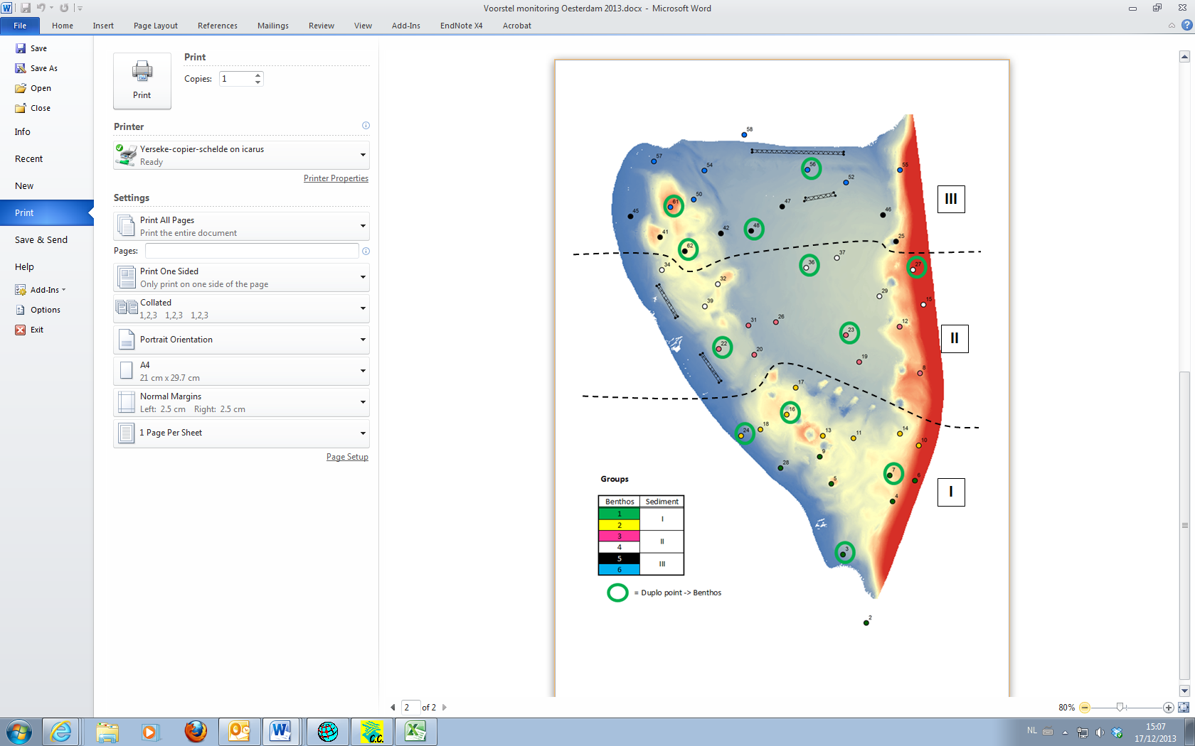



**Field measurements Oesterdam**

**6 Benthos groups of 4 students:**

* Lug worms count (10 quadrants)

Are Lug worms present? Yes/No. Throw the quadrant (50*50 cm) ten times at a random place. At each place you count the number of lugworm heaps in the quadrant and note the number down on the Sample card.

* Environmental picture:

First, take 1 picture of the sample card of the sample point. This way we know where the pictures are taken. Then take 4 environmental pictures in different wind directions. At last take 1 picture from a height of 1 m of undisturbed soil within a representative quadrant (50*50 cm). That is 6 pictures at each site.

* Benthos

Take 3 cores till the mark and sieve the sand in water. Collect the residue (the benthic organisms and shells in the sieve) from the sieve. Put the residue in the jar labelled “Benthos Oesterdam NIOZ” for the sample point where you are. IF YOU ARE AT A MEASURING POINT WITH A GREEN CIRCLE, REPEAT THIS SAMPLING. Put the second sample residue in the jar labelled “Benthos Oesterdam HZ”

* Crabs, shrimps and cockles

Throw the quadrant (50*50 cm) at a random place at the sampling site. Put the top 5 cm of the sediment within the quadrant in the net. Sieve it in the water and put the residue in the provided jar (labelled Crabs e.g.). Repeat this at one other location at the same sampling site and put the residue in the **same jar**.

**3 ‘sediment’ groups of 4 student:**

Each group measures 16 sampling points

* Grain size and organic content

First take 1 sediment sample of the top 3 cm with the bigger syringe (spuitje). Put this sample in the small jar.

Then take 5 sediment cores using the whole bigger syringe. Place them in the bigger jar.

* Chlorophyll

Take 3 times the top 1 cm of sediment with the small syringe (spuitje). Put all three samples in the small bag, labelled for the sample point and store the bag in the larger freezing bag with the freezer pack.

**1 Group dGPS + sediment compactness 4 students:**

This group measures all sampling points

* Measuring sediment height with the dGPS
* Explained by supervisor in the filed
* Measuring sediment compactness with a Penetrologger . 3 measurements at each sample site. Measuring technique will be explained in the field.

Group 10

**Height & sediment compactness measurements**:

Monday in the field:

* Measure the height (Dgps) of all 60 points where benthic will be sampled
* Use at the same points the Penetrologger to measure the sediment
* compactness. Measure 5 times at one location
* Note the depth at which an oxidation layer (black layer) starts (in cm)
* After measuring the 60 sample points walk in strait lines over the tidal flat to
* the height of the total tidal flat.
* Measure the sediment compactness to get a good overview of the area.

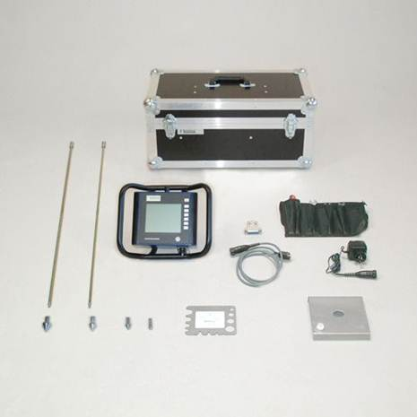

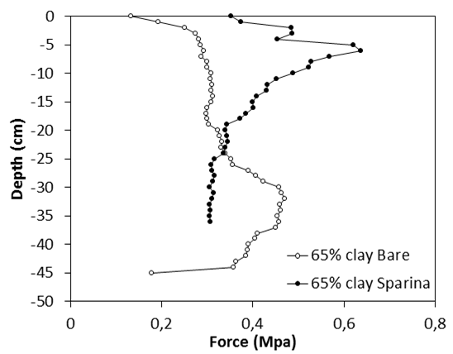

Group 11 and 12







Mini Sand Nourishments Method

This technique is an easy way to assess the behaviour of the sediment transports and sedimentation in and around the reef.

The principle behind this technique is to create, with sand, a circular shape with 0,66 m radius and a volume of approximately 0,50 m3 which means the use of 2 “mudcar” with sand. This circular shape should be as homogenous as possible.

The Setup method for implementing the Mini Sand Nourishments is the following:

1. Placement of a Bamboo stick on the place where is going to be performed the mini sand nourishment;
2. Provision of enough sand, with the “mudcar”, to create the necessary volume (approximately 0,50 m3);
3. Creation of a volume with 0,66m of radius centred in the bamboo stick, special attention is needed to the homogeneity of the volume.
4. Measure the length of the bamboo stick outside the sand nourishment.

After a minimum period of at least 48h it is possible to proceed to measurements.

The setup for the measurements is the following:

1. Draw a circle with 1,0m of radius and centre on the bamboo stick:
2. Draw the new shape made by the previously deposited sediment.
3. Mark with the help of a compass the North and seven other cardinal points( South, East, West, North-East, North-West, South-East and South-West)
4. Register in Each direction the length of the sediment
5. Register the direction and location of the highest sediment point;
6. Measure the length of the bamboo stick outside the sand nourishment.

This technique gives an expedite way of measuring not only the main direction of the hydrodynamics forces but also the main direction of the sediment transports in the place followed by the rate of erosion for a given period of time and weather conditions.

## Lab Work

## Analysis of Benthic Samples

### PREPARATION

1. Before the analysis, each sample should be stained with a solution of Rose bengal. This dye binds specifically to proteins, which produces a clear contrast between the living animal material and the dead residue collected in the samples.

Bengal Rose (already preperated):

Create a solution with a ratio of 1 gram Bengal rose (powder) in 100 ml of 96% Ethanol. From this solution add a SMALL dash to the sample so that the liquid is a clear, pink color. Carefully tilt the sample several times, so that the dye spreads evenly over the whole sample. Ensure that sand and silt on the bottom also becomes suspended. Leave the sample to rest for at least 1 hour to give it time to attach to the animal material.

1. In the wet area in the Ecolab, sift the sample above a bucket containing a frame using two stainless steel sieves of 1 mm and 0.5 mm fitted one on top of the other.
2. Sorting will be done on a table in the Ecolab in photography trays or possibly using a microscope.
3. Each sample processed will have a unique sample number. This should be listed on a specifically designated data sheet provided in the lab.

On the form record:

* The sample number
* The date of collection
* Your name
* The date the sample is analysed

*For an explanation of how the samples will be analysed, see: Methods, Analysis and Sorting*

1. Keep the completed data sheet in the sample during the analysis and, after the analysis is complete, return it, along with the sample to the supervisors.

### METHODS: SORTING

Rinsing

1. Before you start the analysis, complete the data sheet using the sample number of the container.
2. Rinse the sample in the wet area of the eco-lab, above the bucket in the sink. Put the sample through two sieves of 1mm and 0.5mm assembled one on top of the other (1mm sieve on top, 0.5mm sieve on the bottom). Gently pour the contents of the sample container into the sieves and rinse them with tap water, so that the finer material falls through the meshes.
3. *Divide large samples into two or more portions and rinse each separately. Do not add too much of a sample to the sieves at one time, as you will risk it clogging and overflowing which would mean animals may be lost from the sample.*
4. Finally, properly clean the sample containers (inside and outside) and any text is removed with acetone in the fume cupboard.
5. Make sure that you know which sample number corresponds to the sample at all times!!!

Sorting the samples

1. Sort the sample into sieve groups; the first group from the 1mm sieve and the second from the 0.5mm sieve . For each sieve group, place a small amount of sediment in a photography tray and spread it evenly over the tray. Add a thin layer of water. Do not overfill the tray or it will become too cluttered.
2. NOTE : There may be animals stuck in the mesh of the sieve, so inspect the sieve carefully and make sure nothing left!
3. Place the photography tray on a table in the Ecolab provided with light and extraction.
4. On the base of the tray there will be lines/stripes, use these to keep track of where you are up to in the sample. Inspect the sample line by line and carefully remove all the ‘coloured’ organisms from the sample with a set of ‘blunt’ tweezers. (NOTE: there may also be unstained organisms present in the sample). Search through the sample until no more organisms are found (do this at least twice) and then let one of the supervisors check it before it is disposed of in the appropriate bucket.
5. This way you can carefully inspect your whole sample so that everything is sorted out from the sieve.

Sorting the organisms

1. Once the organisms are removed from the sediment in the photography tray they can be sorted into different groups.
2. The lines on the bottom of the tray will help you to systematically search through the organisms, giving you a clearly defined path to work so that you do not miss a spot.
3. Remove all the organisms from the tray with a ‘blunt’ tweezers place them in a petri dish with distilled water.
4. You can already distinguish the organisms between Polychaetes (worms) , Crustaceans (crabs, shrimp, amphipods etc) and Molluscs (snails and bivalves). Place these into separate petri dishes but do not use unnecessarily large petri dishes for a sample.
5. Handle the material carefully , so that no organisms break or get crushed.
6. Write the sample number and sample date on ALL petri dishes
7. Once you have finished sorting a sample, seal the petri dishes are with a lid and keep it ready for the species determination.

### METHODS: SPECIES DETERMINATION

Species Determination

*It is assumed here that all samples are already stained and sorts so that the samples consist only of ‘live’ material.*

1. Use a microscope with light source, tweezers and possibly a needle. Put it in a suitable place on a table in the Ecolab .
2. Work from petri dish to petri dish in the same sample so that you finish one sample completely before you start another. Do not mix up samples!
3. If the sorting of the species went well, there is already a small distinction between Polychaetes (worms) , Crustaceans (crabs, shrimp, amphipods etc) and Molluscs (snails and bivalves). These can now be developed further and counted.
4. Polychaetes (worms) are difficult to distinguish from each other. This can only be done by looking at the fine details, however the obvious different species can be distinguished from each other. Using the literature, try and identify the species. Ask the supervisors for help and always let them check that you have the correct species! Count only the heads of the specimens and record this information on the data sheet.
5. Small crustaceans (shrimp, amphipods etc) are sometimes difficult to distinguish from each other. This can only be done by looking at the fine details, however the obvious different species can be distinguished from each other. Using the literature, try and identify the species. Ask the supervisors for help and always let them check that you have the correct species! Count only the heads of the specimens and record this information on the data sheet.
6. Decapoda/Brachyura (crabs) can be identified by the shape of their carapace (shell) and bij the shape off the legs. Check the literature or ask for help from the supervisors. Once you have identified the species, count only the heads/mouths and fill in the details on the data sheet.
7. Gastropoda (snails) such as mudsnails , periwinkles and slipper shells can be distinguished from one another and count only the mouths (of the shells) , note this information on the data sheet.
8. Bivalves (clams and cockles) can be distinguished from the molluscs. Try to identify these further using the literature (let the supervisors check that you have it correct!). Make a count of all the locks and record this information on the data sheet.
9. Once the entire sample is processed , counted and recorded , it can be in its entirety, including data sheet, handed to the supervisors before you start on a new sample.

Quality Assurance

1. NOTE Each data sheet must be correctly and fully completed for each sample!

2. NOTE Each jar/petri dish must be properly labeled showing where it comes from.

3. Record all data at all times on the data sheet and let the supervisors check everything!!

## Analysis of Sediment Samples

Grain size distribution analysis is used to classify soils for engineering purposes, and other geotechnical applications. ASTM D422 explains about the procedure of grain size distribution analysis. Grain size distribution is done with sieve analysis and/or hydrometer analysis. This chapter deals with the sieve analysis only.

### Determination of organic content in the sediment

* Mass balance with 0.001g resolution
* drying oven
* muffle furnace
* crucibles

**Procedure**

1. Write down the number on the crucible
2. Weigh the crucible using the mass balance
3. Place the sample in a crucible and measure the combined mass
4. Dry the sample in the oven at 103◦C until dry (aprox. 7days)
5. Re-weigh the crucible + sample. Subtracting the crucible weight to calculate the dry weight
6. Set the muffle furnace temperature to 550◦C and leave the crucible in it for 2 hours.
7. Remove the crucible from the furnace and allow to cool for 30 minutes in a exicator.
8. Re-weigh crucible + subsample. The weight difference between the ash free dried sample and the dry weight sample is the burned organic content (ash free dry weight).
9. Expressed the organic content as a percentage of the dry weight of the sediment to be able to compare the different locations with each other

$$Organic Material Content= \frac{Dry weight-Ash weight}{Dry weight} ×100\%$$

|  |  |  |  |  |  |  |  |  |
| --- | --- | --- | --- | --- | --- | --- | --- | --- |
| A | B | C | D | E | F | G | H | I |
| 1 | Number crucible | Weight crucible (g) | Weight crucible + wet weight (g) | Weight cup + dry weight (g) | dry weight (g) | Weight cup + ash free dry weight (g) | Ash free dry weight (g) | % organic matter |
| 2 |  |  |  |  | =E2-C2 |  | =E2-G2 | =(H2/F2)*100 |
| 3 |  |  |  |  | =E3-C3 |  | =E3-G3 | =(H3/F3)*100 |

### GRAIN SIZE DISTRIBUTION ANALYSIS

* Mass balance with 0.01g resolution
* drying oven
* crucibles
* burners
* different sieves + pan and cover
* Mechanical sieve shaker
* Stop watch
* Empty bowl
* Brush

**Procedure**

1. Measure weight of an empty bowl.
2. Collect approximately 100 g of dry soil sample.
3. Break the soil samples into individual particles by hand or any other tool such as mortar and pestle.
4. Pour the soil into the bowl and weigh the mass of soil and bowl.
5. Prepare a stack of sieves, largest size sieve at the top and smallest sieve size at the bottom. The sieves will have a maze width of: 0.063 mm, 0.125 mm, 0.250 mm, 0.50 mm, 1.0 mm, and 2.0 mm.
6. Pour the soil into the top sieve, and cover it.
7. Put the assembly into a mechanical shaker, tighten all the screws, and turn the shaker on.
8. Shake the assembly for about 5 minutes.
9. Wait for about 3 minutes, and remove stacks of sieve.
10. Weigh the soil mass that is retained on each sieve and the bottom pan. For this, empty the bowl and measure its weight. Fill the bowl with the soil retained in each sieve. Then measure the weight of the bowl and soil. Populate the table 1.
11. Sum up the quantity of soil retained on each sieve and the pan. If the total weight is less than the initial weight by more than 1%, repeat the procedure.
12. Clean the sieves by shaking, do not use a brush.
13. Weigh the sieves again an continue with all samples
14. Calculate the particle size according to the protocol.

$$\% of sediment retained= \frac{Weight of sediment remained on sieve}{Total weight of sediment used for sieving} ×100\%$$

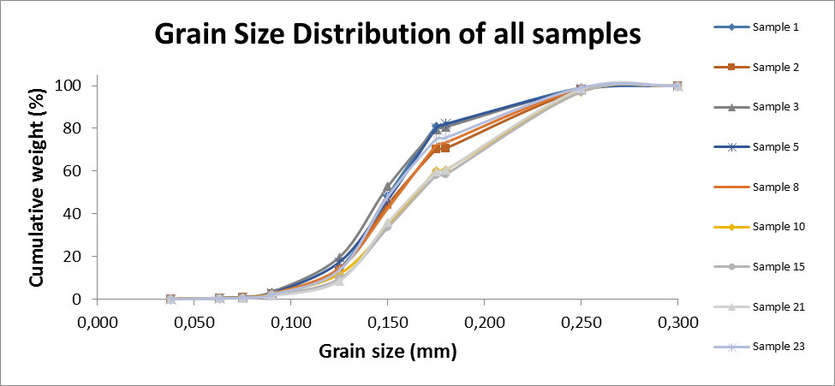

**Calculations**

1. Calculate the % of soil retained on the ith sieve



1. Calculate the cumulative % of soil retained on the ith sieve



1. Calculate the % of soil passing through the ith sieve



1. Populate the attached table completely using the above equation.
2. Make a graph of particle size in mm (log scale) in X-axis and % finer (in arithmetic scale) in Y-axis using the graph paper shown in figure 1. You can use your own “excel spread sheet” or other computer programs to make this graph.
3. Determine D10, D30, and D60 from the graph, which correspond to the particle size for 10% finer, 30% finer, and 60% finer. Determine the D50, D15, D85, and D90 also.
4. Calculate uniformity coefficient (Cu) and coefficient of gradation (Cc) using the following equations.



Note:

* D10 is also called effective size and is used to estimate coefficient of permeability.
* Cu shows whether the soil is well graded or poorly graded.
* Cc complements Cu to evaluate whether the soil is well graded or poorly graded, or gap graded.
* D90, D15 and D85 are used to design filters. D50 is used in liquefaction analysis.

Quality Assurance

1. NOTE Each data sheet must be correctly and fully completed for each sample!

2. NOTE sample must be properly labeled showing where it comes from.

3. Record all data at all times on the data sheet and let the supervisors check everything!!