**Field measurements Oesterdam 19-12-2013**

**6 Benthos groups of 6 students:**

* Lug worms count (10 quadrants)

Are Lug worms present? Yes/No. Throw the quadrant (50*50 cm) ten times at a random place. At each place you count the number of lugworm heaps in the quadrant and note the number down on the Sample card.

* Environmental picture:

First, take 1 picture of the sample card of the sample point. This way we know where the pictures are taken. Then take 4 environmental pictures in different wind directions. At last take 1 picture from a height of 1 m of undisturbed soil within a representative quadrant (50*50 cm). That is 6 pictures at each site.

* Benthos

Take 3 cores till the mark and sieve the sand in water. Collect the residue (the benthic organisms and shells in the sieve) from the sieve. Put the residue in the jar labelled “Benthos Oesterdam NIOZ” for the sample point where you are. IF YOU ARE AT A MEASURING POINT WITH A GREEN CIRCLE, REPEAT THIS SAMPLING. Put the second sample residue in the jar labelled “Benthos Oesterdam HZ”

* Crabs, shrimps and cockles

Throw the quadrant (50*50 cm) at a random place at the sampling site. Put the top 5 cm of the sediment within the quadrant in the net. Sieve it in the water and put the residue in the provided jar (labelled Crabs e.g.). Repeat this at one other location at the same sampling site and put the residue in the **same jar**.

**3 ‘sediment’ groups of 2 student:**

Each group measures 16 sampling points

* Grain size and organic content

First take 1 sediment sample of the top 3 cm with the bigger syringe (spuitje). Put this sample in the small jar.

Then take 5 sediment cores using the whole bigger syringe. Place them in the bigger jar.

* Chlorophyll

Take 3 times the top 1 cm of sediment with the small syringe (spuitje). Put all three samples in the small bag, labelled for the sample point and store the bag in the larger freezing bag with the freezer pack.

**1 Group dGPS + sediment compactness 2 students:**

This group measures all sampling points

* Measuring sediment height with the dGPS
* Explained by supervisor in the filed
* Measuring sediment compactness with a Penetrologger . 3 measurements at each sample site. Measuring technique will be explained in the field.

**1 Group for installing reflectors on poles 2 students**

This group will install reflectors on about 25 poles. The reflectors will be used for a 3D scan of the area. You will help with nails, hammers and chisels.

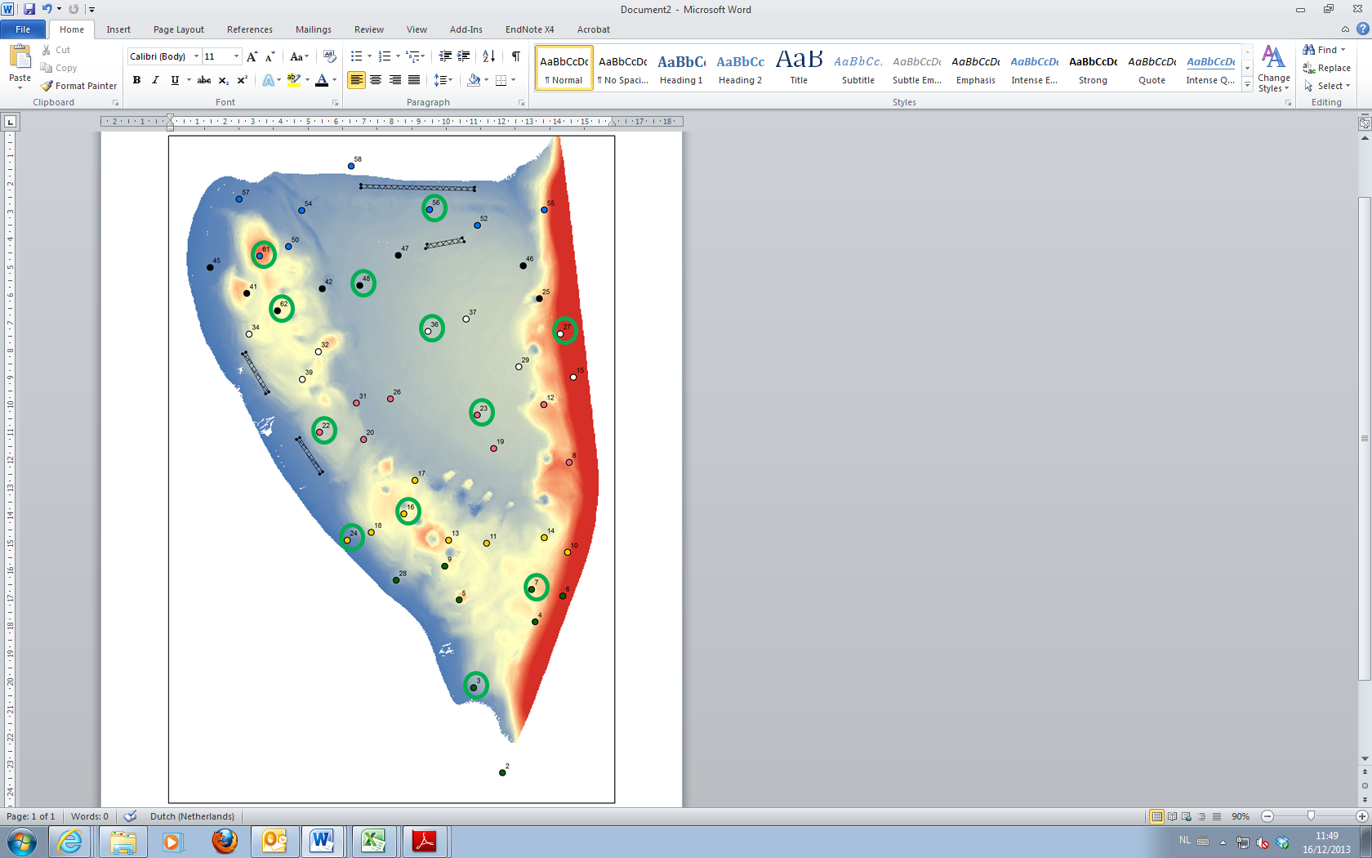All sampling points Oesterdam. Different colors indicate different Benthos groups. Each group will be fitted with a GPS and a list of coordinates of the sampling points so they can find the sampling locations in the field.

NOTE: TAKE TWO sediment core samples at sampling points with a green circle!!!

The Sediment group and the dGPS group will get their own map in the field.